Week 5- IBM Capstone Project: Data Visualisation( Done by HH)

<https://dataplatform.cloud.ibm.com/dashboards/d5ee31cb-6927-44fc-87c7-65fd9f408516/view/1d36de0c228c09c042f2eae407cb78507e667355b2bbd002d5d37b490f357597a83f1691c82e180cdc450660fabf430fcb>

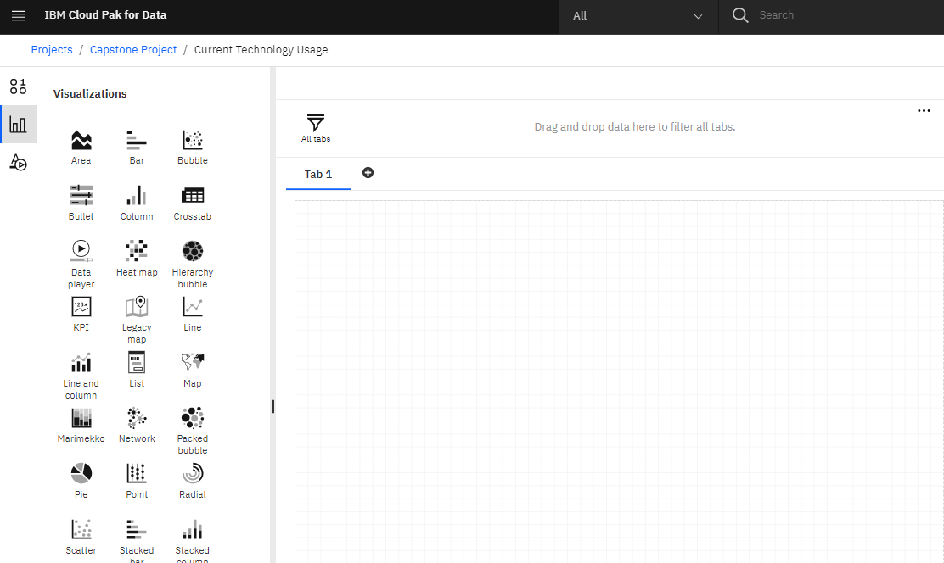

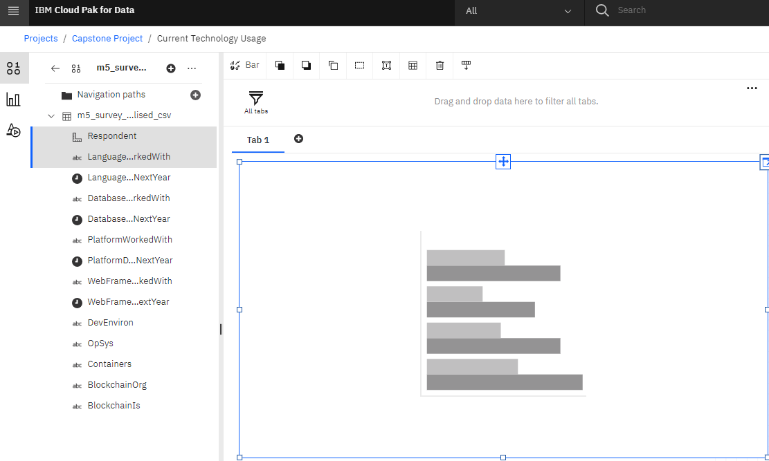

Sort top 10 languages:

Right click the x-axis: Respondent and choose “Top or Bottom”

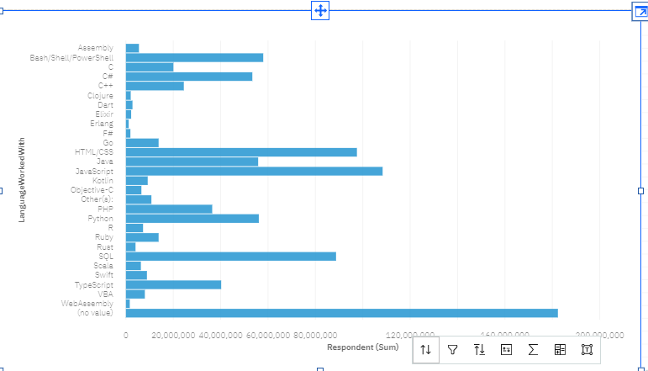

Top or Bottom

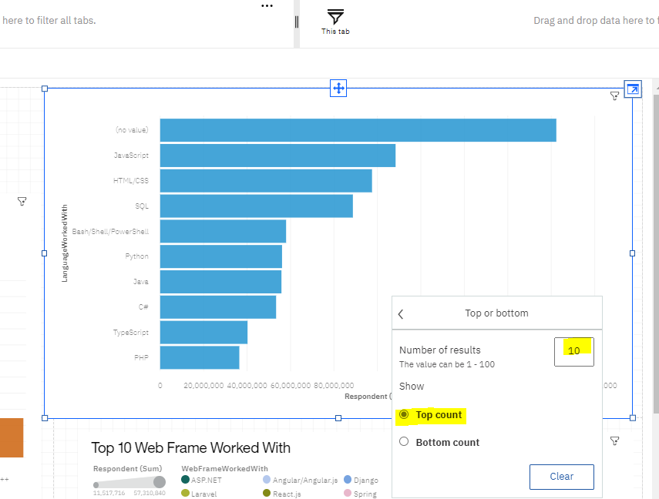

After that, right click on “no value” bar, choose exclude.

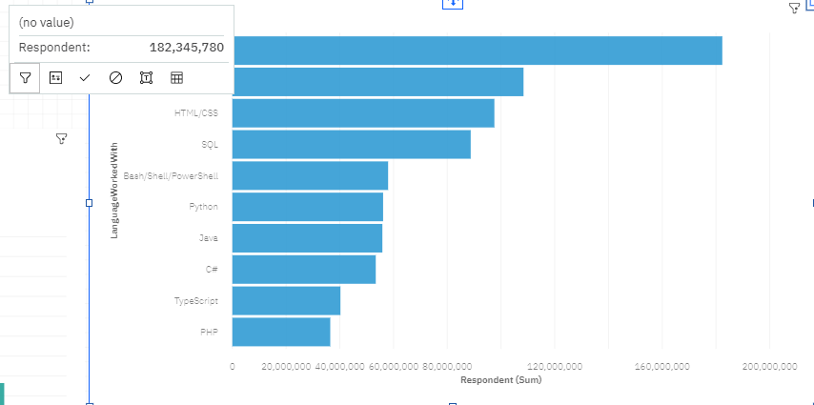

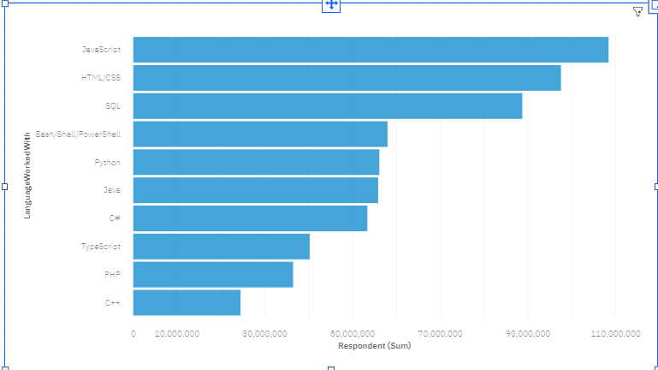

To have different colour for bar:

Under field, color, drag the language worked with to the color field

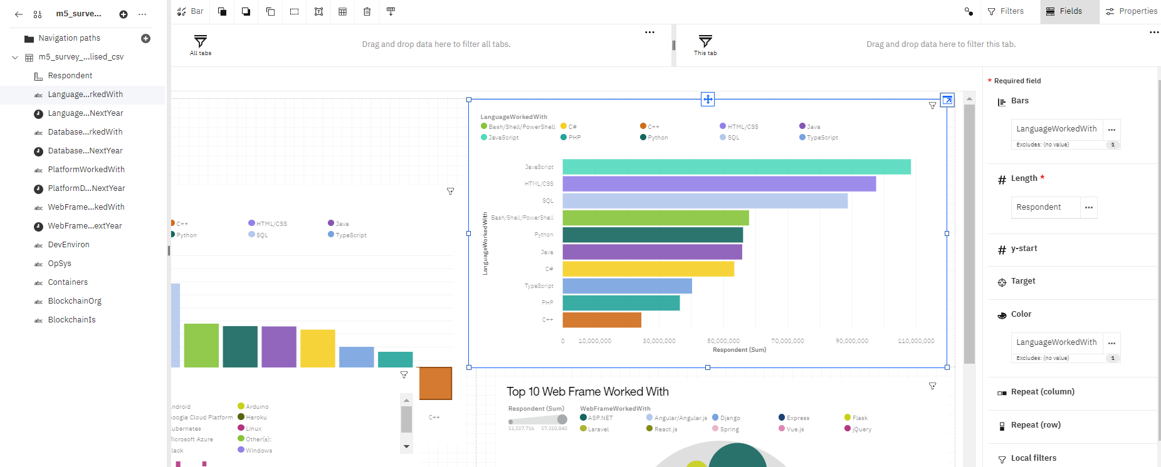

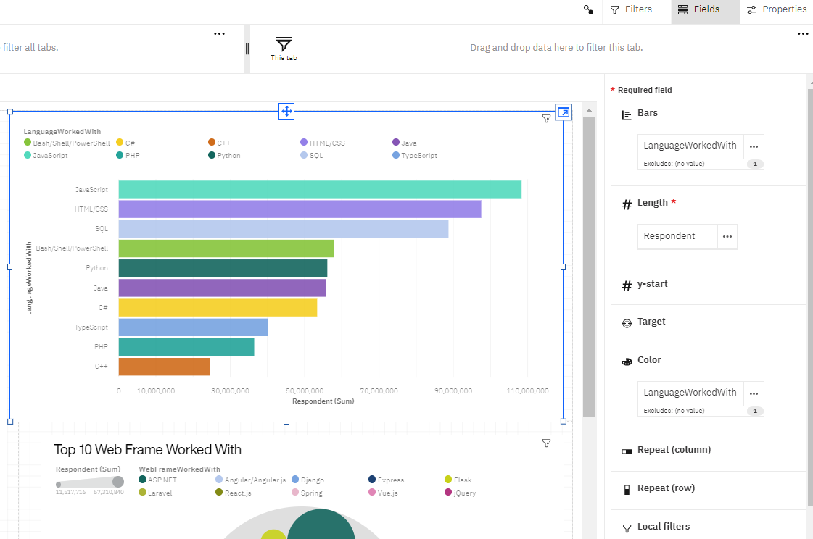

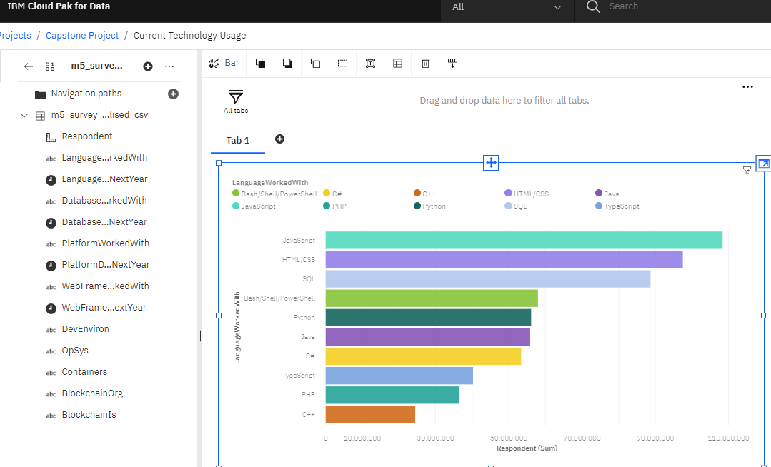

Edit the Title

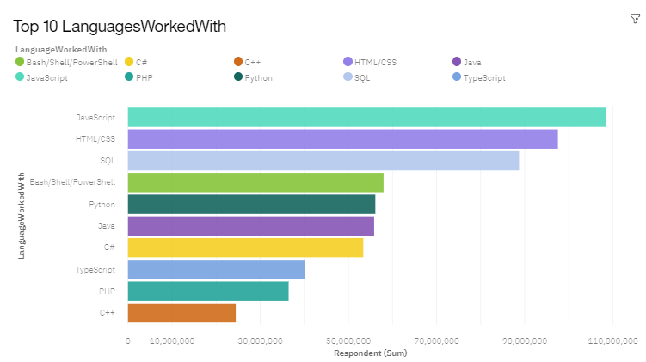

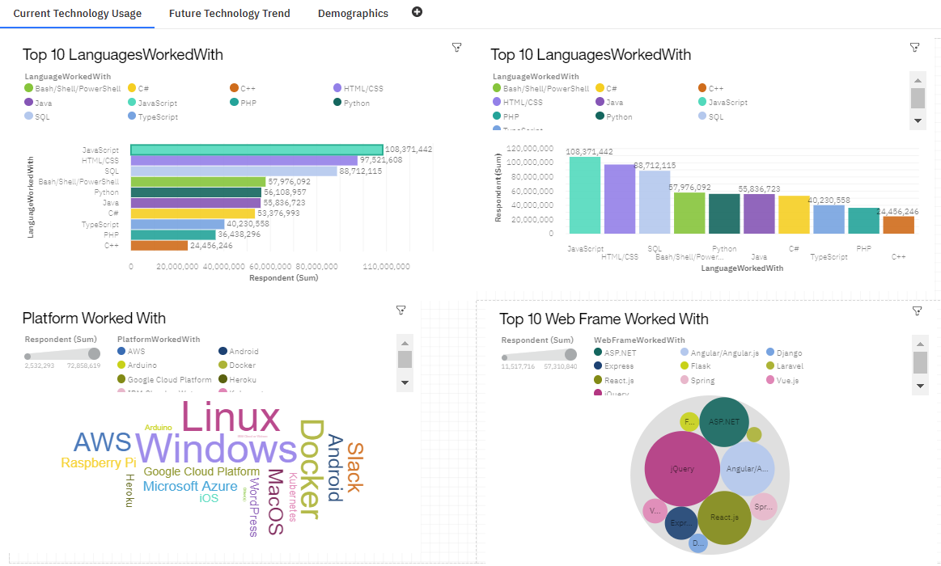

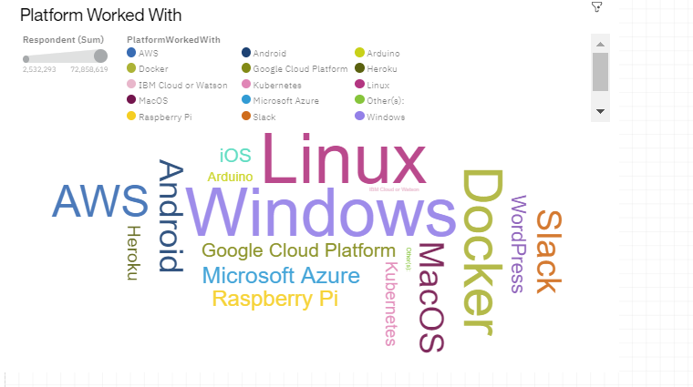

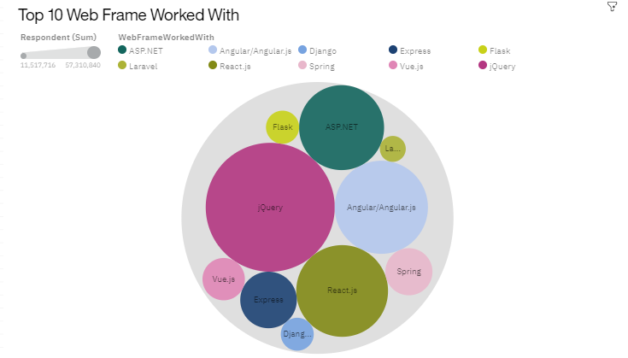

<https://dataplatform.cloud.ibm.com/dashboards/514f1800-cb5d-4e66-ae31-7fbb4476d27b/view/5263a4256f8812e411d0eae407cb78507e667355b2bbd002d5d37b490f357597a83f1691c82e180cdc450660fabf430fcb>

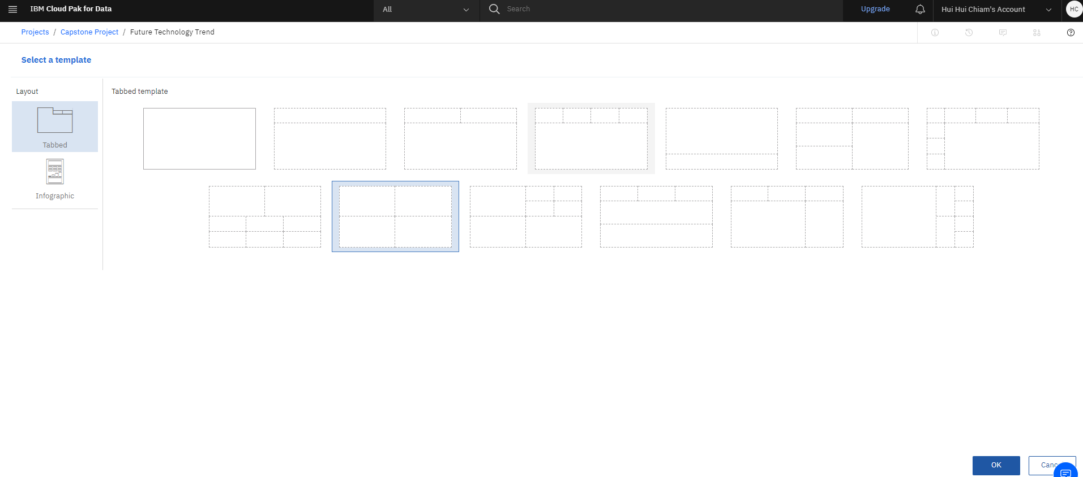

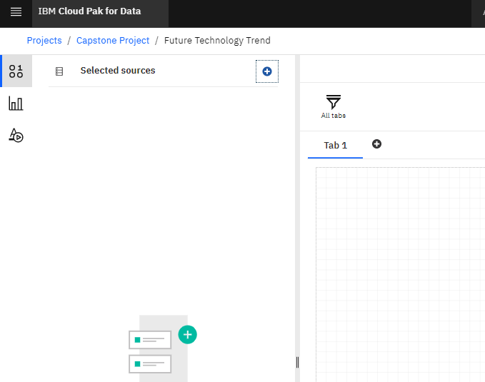 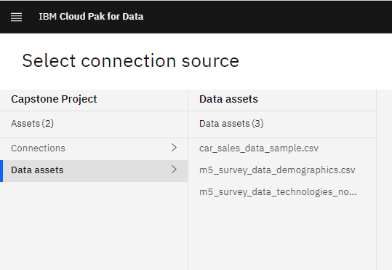

First, we choose the chart type. Bar Chart

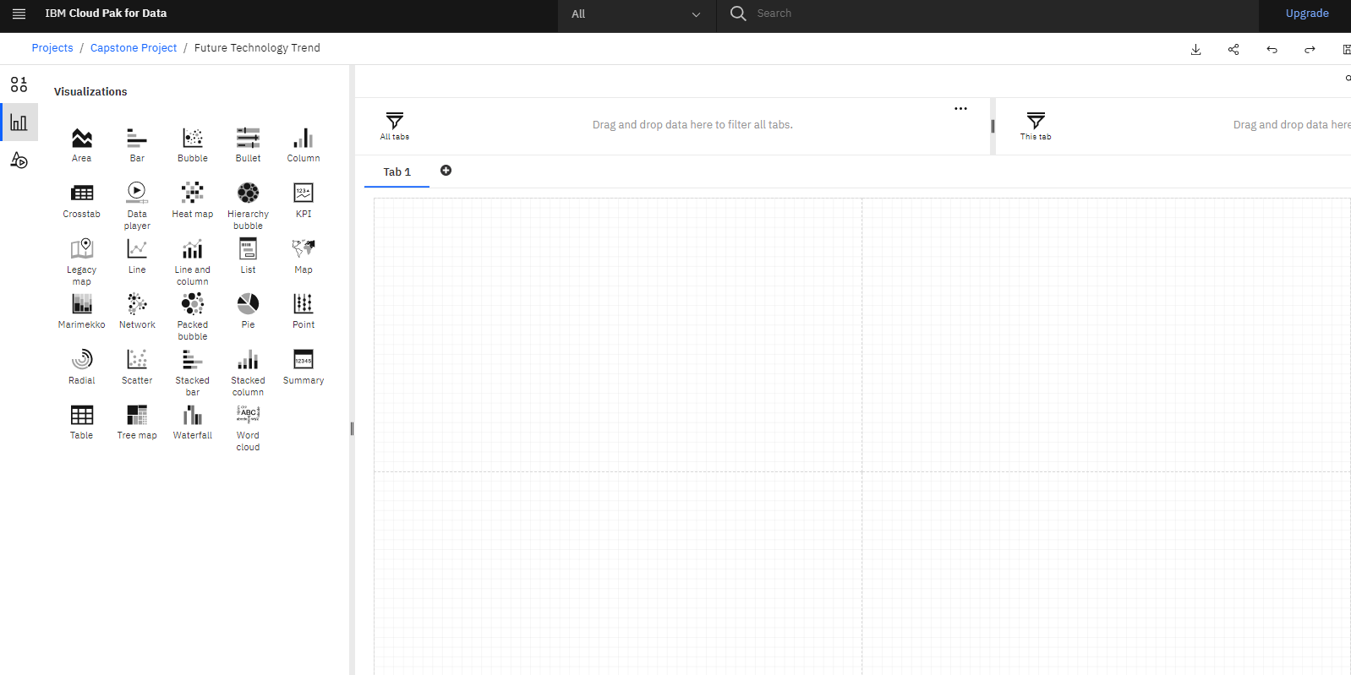

Second, we chosse respondent & LanguageDesireNextYear and drag to the bar chart.

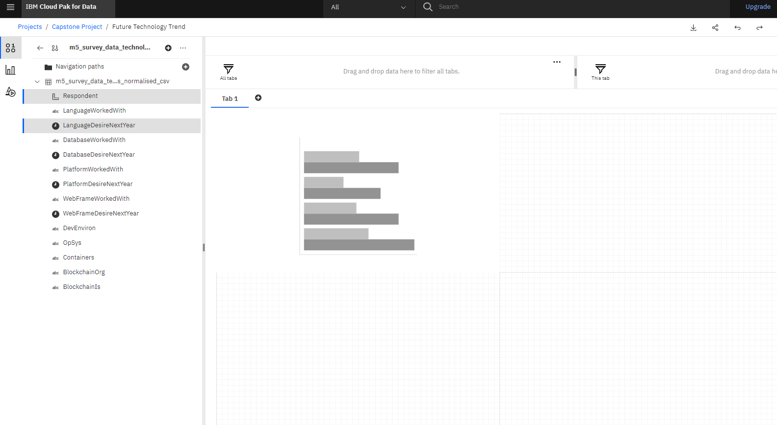

To choose top 10, right click on the x-axis, respondent, choose Top or Bottom.

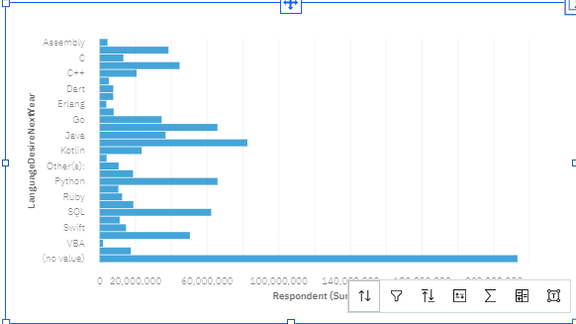

Top or Bottom

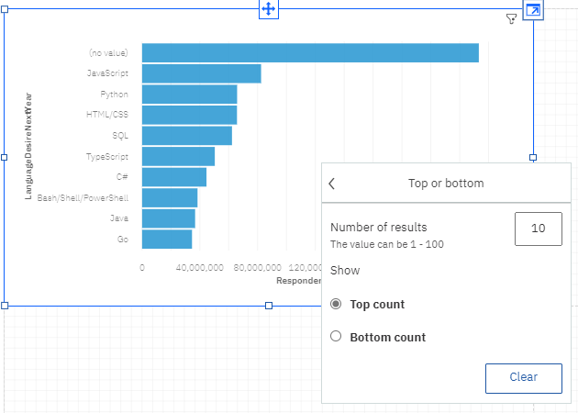

Exclude no value by right clicking the no value and choose exclude.

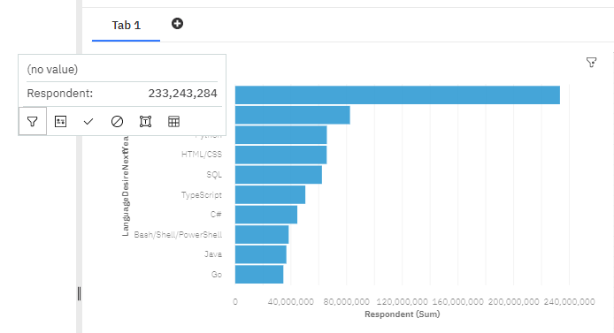

For the bars to have different colours, choose the Fields, and drag the parameter to color.

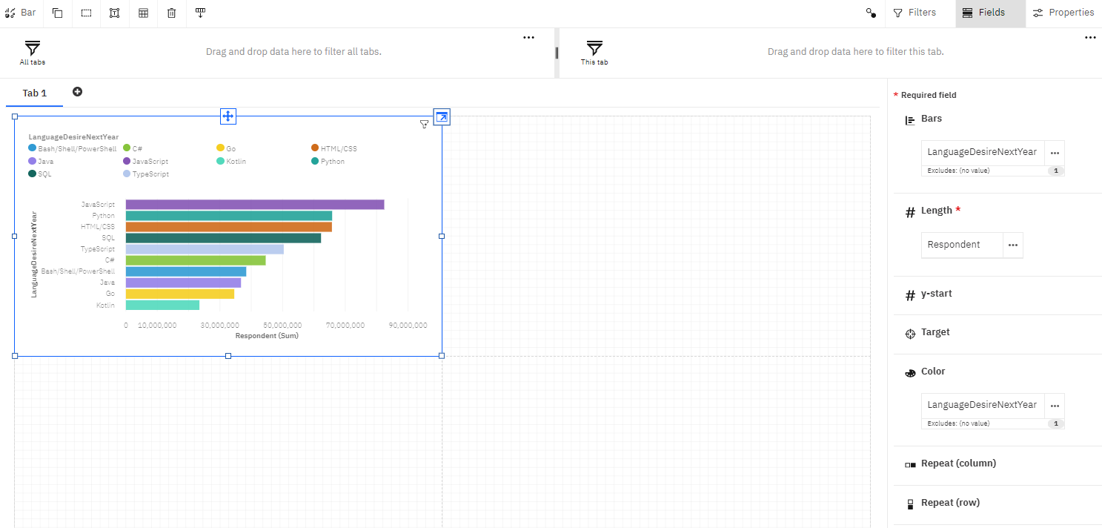

Add the title

